Aposys Data Analysis: GPS_2024-01-24_10-57-49_Weather

Jun. 6th, 2024

Xingyu (Alexander) Liu

# Time series graph

## Soil Temperature at Various Heights and Depths Over Time

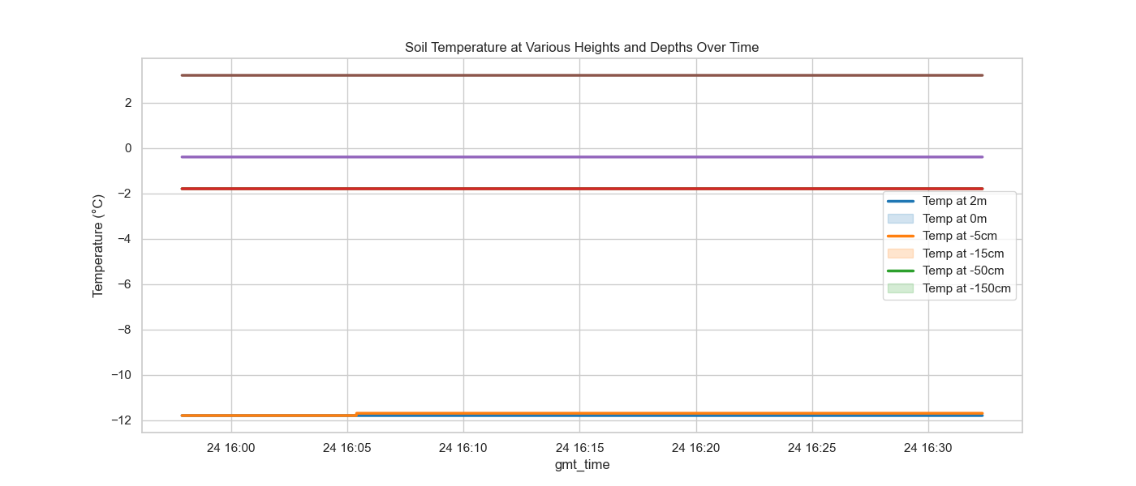

Description: This graph illustrates relatively stable soil temperatures at various depths and heights, with minimal fluctuation during the period observed. The soil temperature is -11.8 °C at 2m, -1.8 °C at -5cm, -1.8 °C at -15cm, -0.4 °C at -50 cm, 3.2 °C at -150cm. The only changed value is the soil temperature at 0m changes from -11.8 to -11.7 Degree Celsius at 16:05.

## Soil Moisture Index at Various Depths Over Time

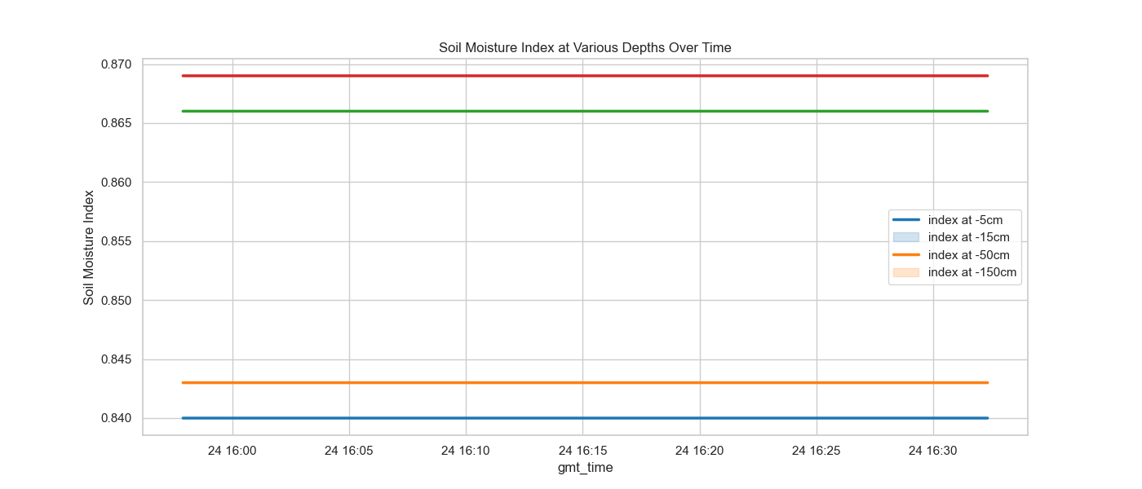

Description: Soil moisture indices show consistent values across different depths, (the soil moisture index are 0.84 at -5cm, 0.843 at -15 cm, 0.866 at -50 cm, and 0.869 at -150 cm respectively) indicating uniform moisture content throughout the soil profile during the measured period.

## Volumetric Soil Water at Various Depths Over Time

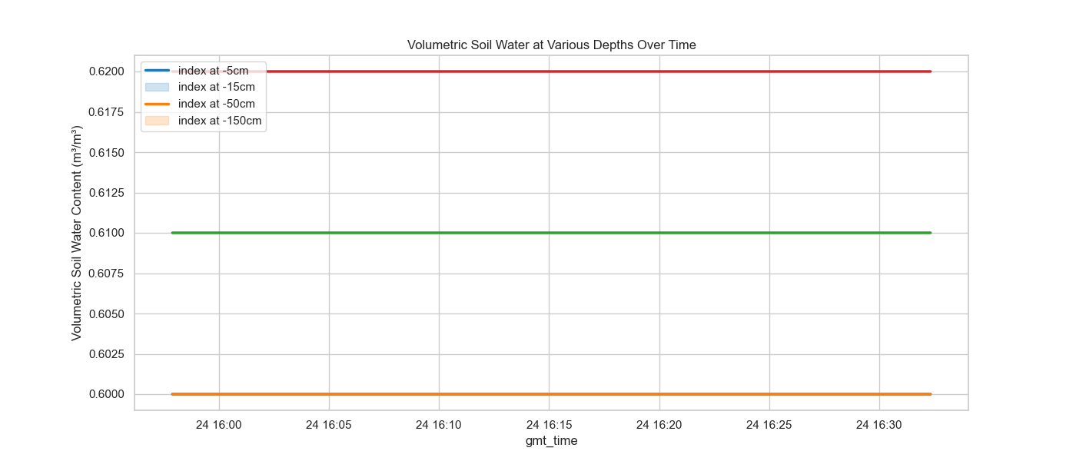

Description: The graph shows the volumetric water content in the soil, which remains steady across all measured depths. This uniformity can indicate well-distributed moisture due to recent precipitation, irrigation, or an inherently moist soil type. The volumetric soil water is 0.6 $m^{3}/m^{3}$ at -5 cm, 0.6 $m^{3}/m^{3}$ at -15 cm, 0.61 $m^{3}/m^{3}$ at -50cm, and 0.62 $m^{3}/m^{3}$ at -150 cm respectively.

## Precipitation Over Time:

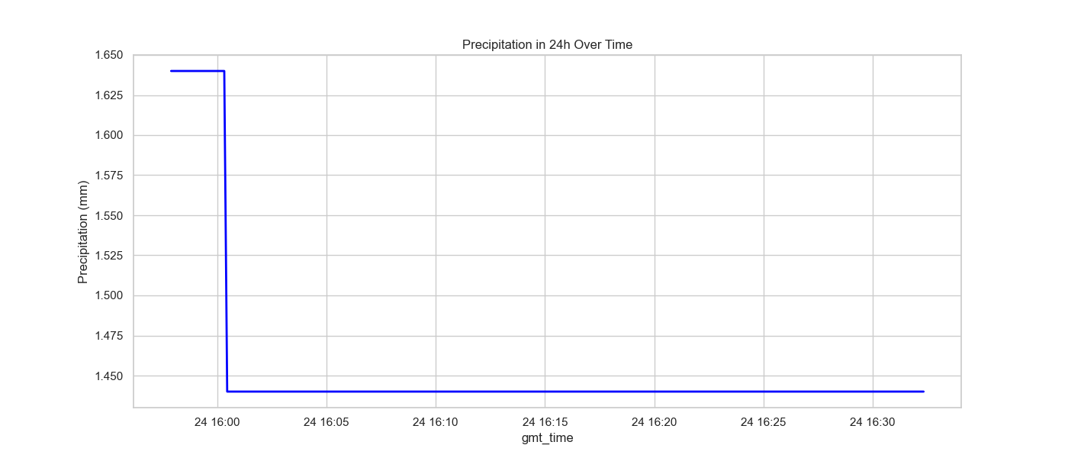

Description: This graph shows the precipitation is 1.64 mm at the beginning of the period, and sharply decreases to 1.44 at 16:00:27.

## Wind Speed at 2m Height Over Time:

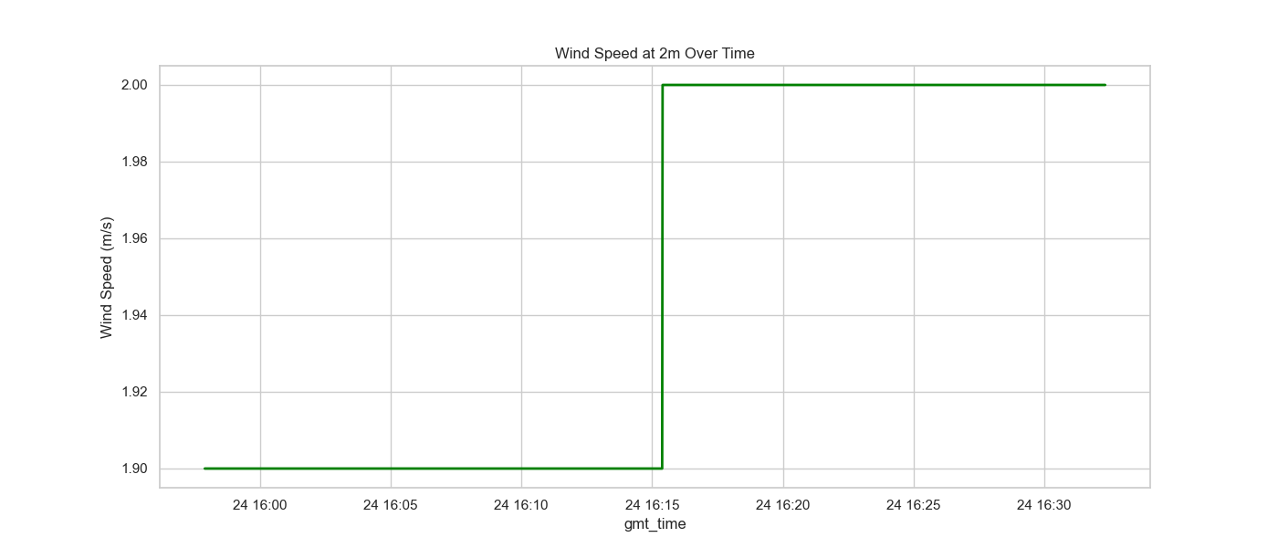

Description: This graph depicts a sudden spike in wind speed at 16:15:24, where it quickly rises from around 1.90 m/s to nearly 2.00 m/s, and then stabilizes. This abrupt increase might indicate a specific meteorological event or a change in weather conditions at the location. The steadiness before and after the spike suggests stable conditions except for this brief period of increased wind activity.

## Effective Cloud Cover Over Time:

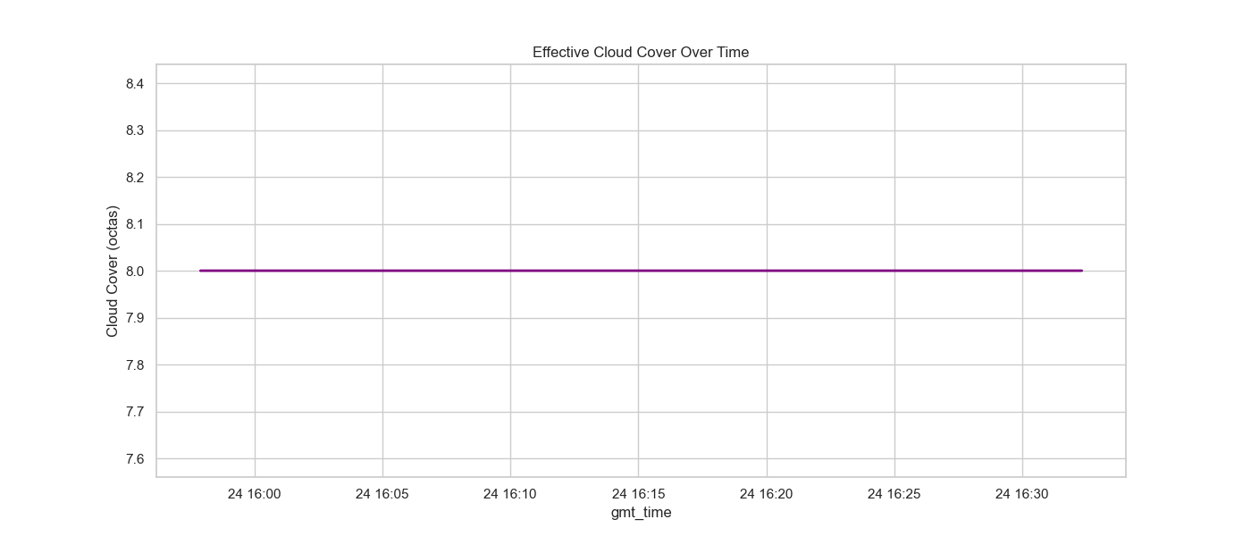

Description: The cloud cover graph shows a constant level of effective cloud cover at 8 octas over the observed period, indicating a completely overcast sky. This uniformity in cloud coverage suggests persistent weather conditions during this timeframe.

## Elevation Over Time:

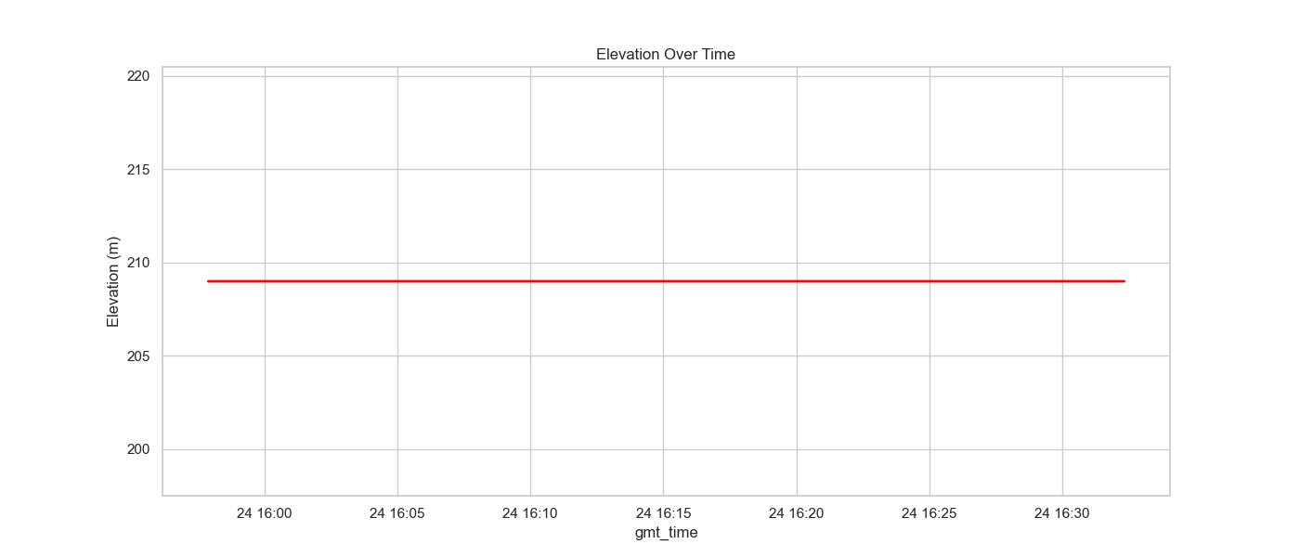

Description: Elevation remains constant throughout the observed period, indicating that the data was collected from a stationary position, or within a flat area where elevation changes are minimal.

# Geospatial graph

### Maximum Temperature at 2m in 24h over Mileage

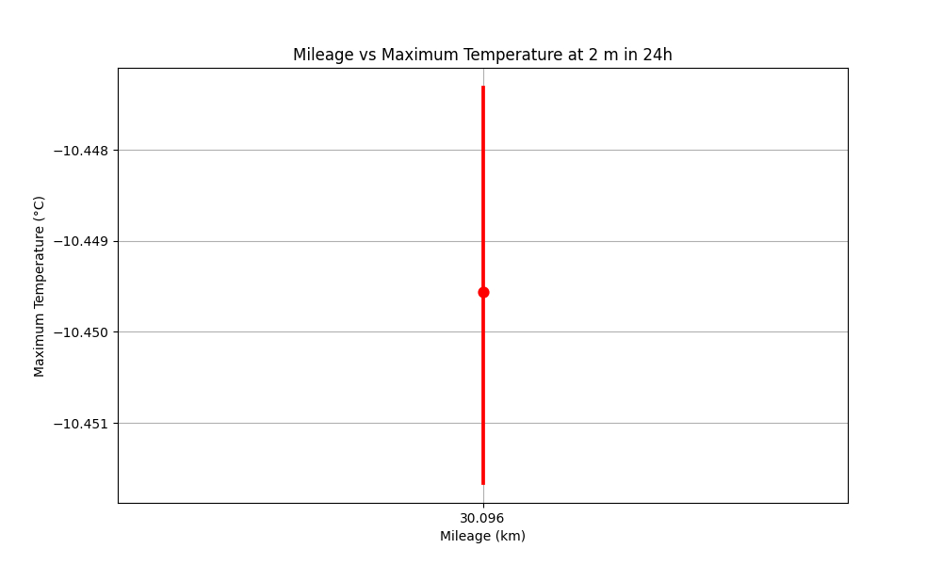

Description: This graph visualizes the relationship between mileage and the maximum temperature observed over 24 hours at a 2-meter height. The red points indicate how the temperature changes with mileage, showing the maximum temperature changes from -11.4 °C to -11.5 °C when mileage is 30.096 km.

### Maximum Temperature at 2m in 6h over Mileage

Description: The peak maximum temperature over 6 hours is -10.8 °C when mileage is 30.096 km.

### Wind speed over Mileage

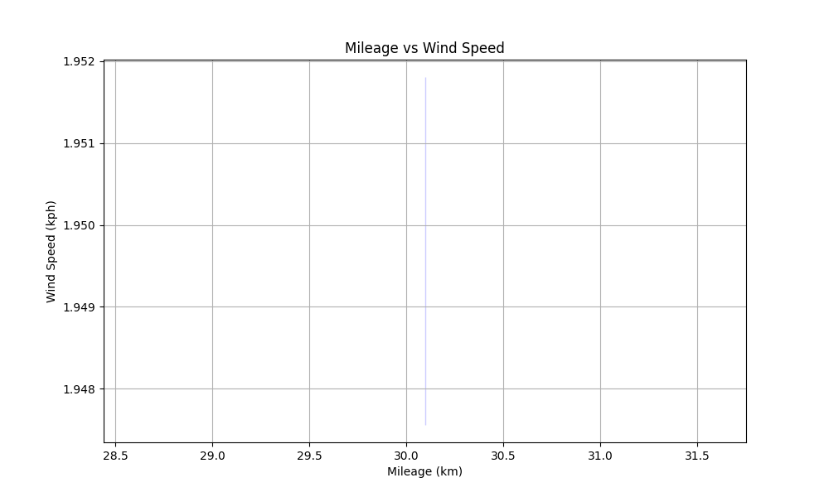

Description: The highest average wind speed is noted at about 30.096 km of mileage, with a wind speed between 1.9 and 2.0 kph.

### Precipitation in 24h over Mileage

Description: The maximum precipitation recorded over 24 hours peaks around 30.096 km, changing from 1.44 mm to 1.64 mm.

### Precipitation in 1h over Mileage

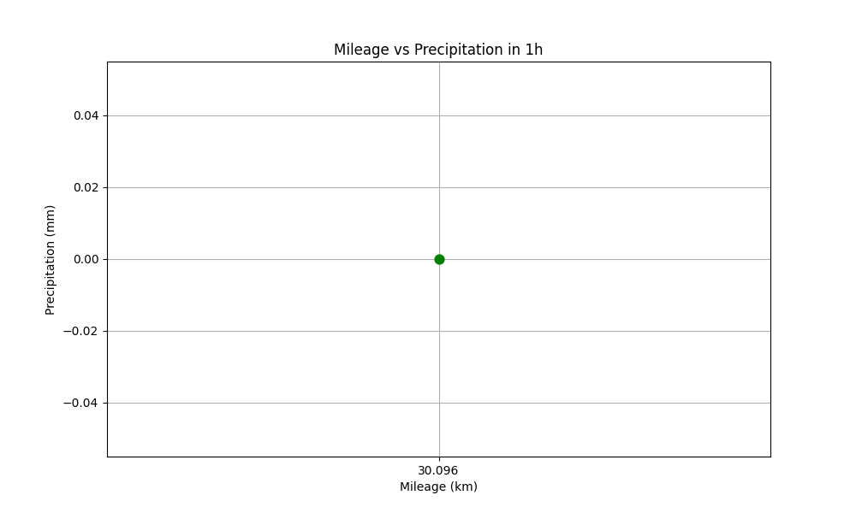

Description: This graph show that the precipitation within 1h is 0 when mileage is 30.096 km.

### Precipitation in 5min over Mileage

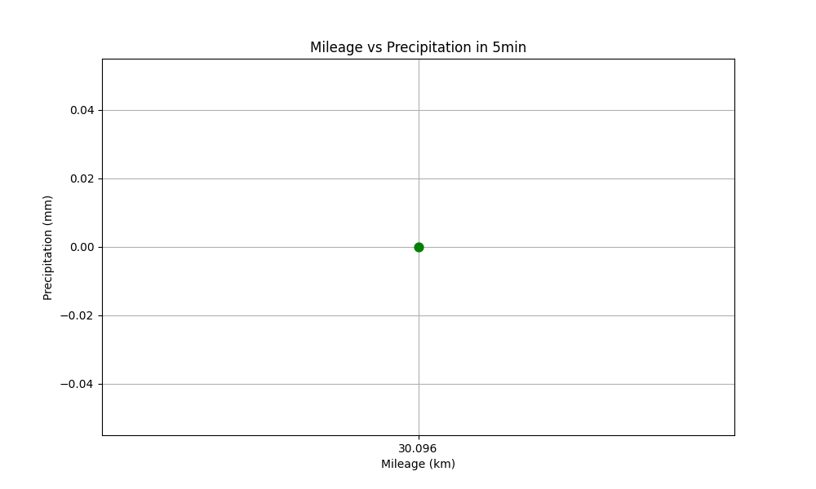

Description: This graph show that the precipitation within 5min is 0 when mileage is 30.096 km.

### Effective Cloud Cover mean in 24h over Mileage

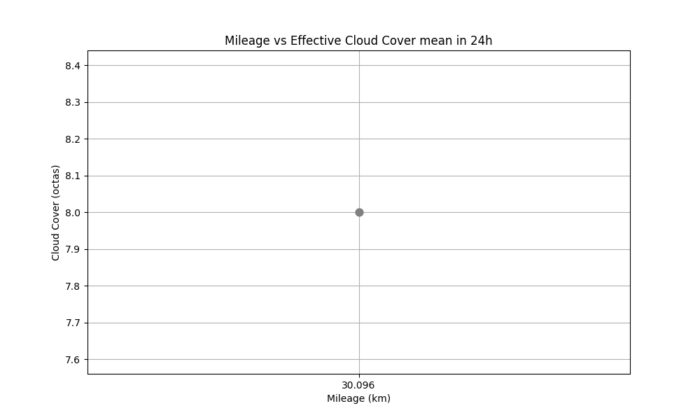

Description: This graph show that the mean of effective cloud cover within 24h is 8 octas when mileage is 30.096 km, indicating a completely overcast sky.

### Effective Cloud Cover mean in 6h over Mileage

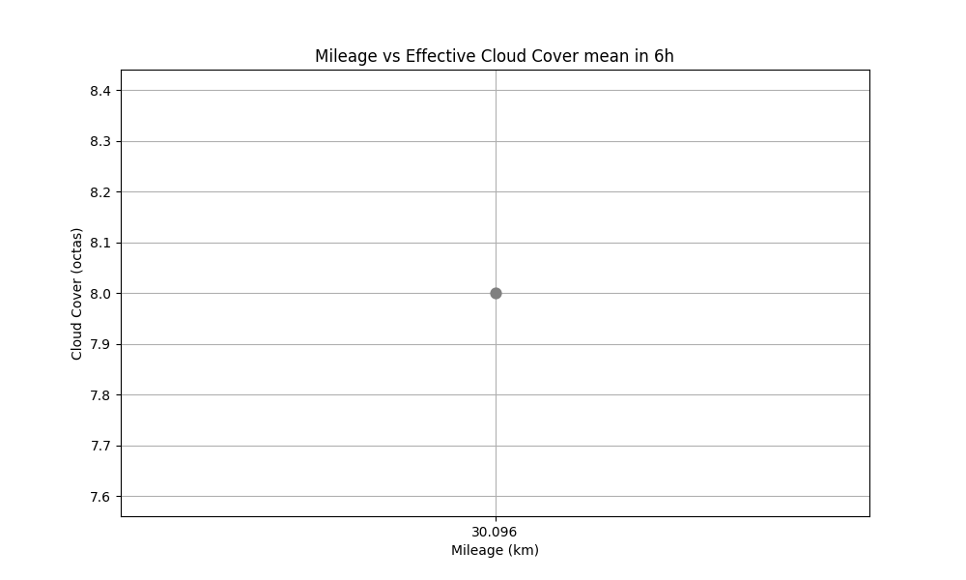

Description: This graph show that the mean of effective cloud cover within 6h is 8 octas when mileage is 30.096 km, indicating a completely overcast sky.

### Effective Cloud Cover mean in 12h over Mileage

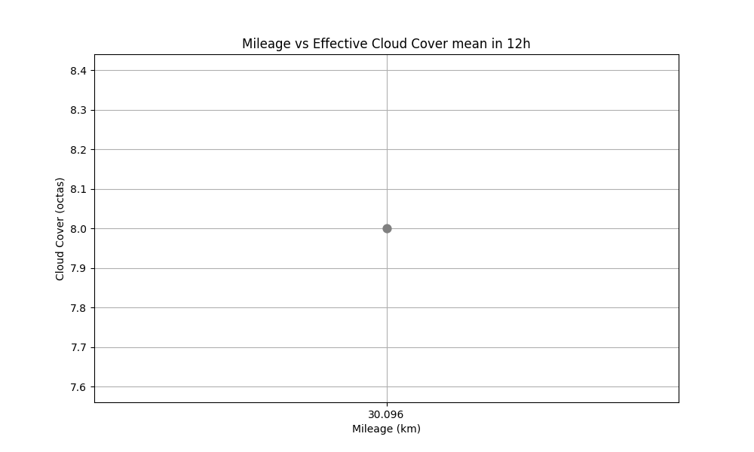

Description: This graph shows that the mean of effective cloud cover within 12h is 8 octas when mileage is 30.096 km, indicating a completely overcast sky.

### Elevation over Mileage

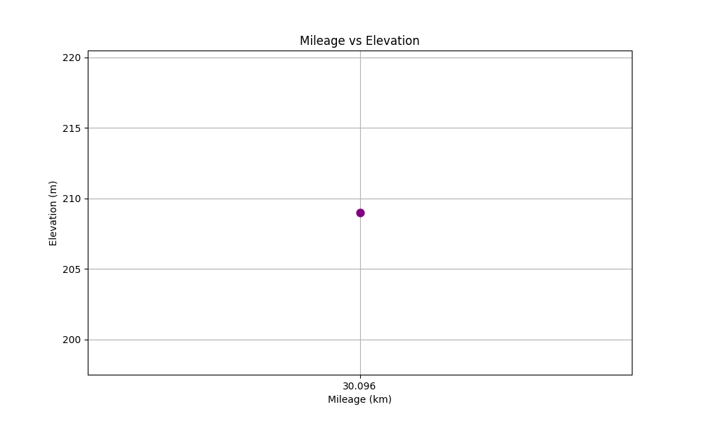

Description: This graph shows that the elevation is 209 m while mileage is 30.096 km.

### Clear Sky Radiation over Mileage

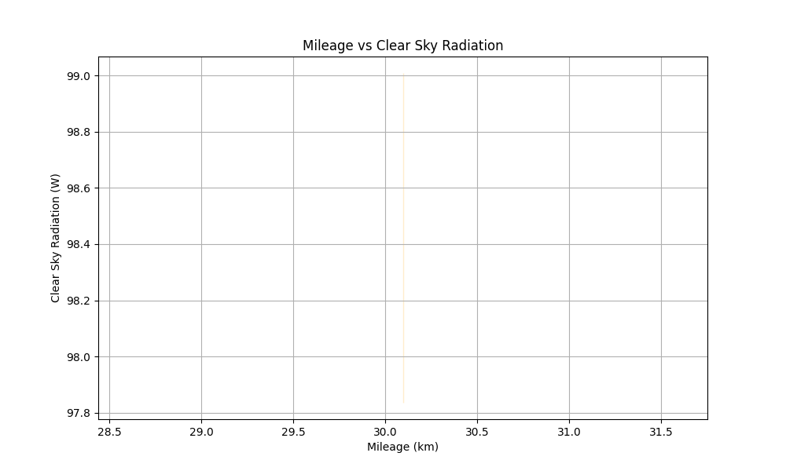

Description: This graph shows that the value of clear sky radiation is changed to 75.1, 81.9, 88.8, 95.7, 102.6, 109.4, and 116.1 respectively while mileage is 30.096 km.